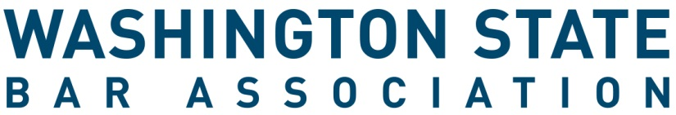

Board of Governors Application Form
At Large Governor (Young Lawyer)
A Young Lawyer is defined in the WSBA Bylaws as an Active lawyer member of the Bar are considered a young lawyer until the last day of December of the year in which the member attains the age of 36 years or until the last day of December of the fifth year after the year in which such member first was admitted to practice as a lawyer in any state, whichever is later.

All Application materials must be received by 5 p.m. PST on Wednesday, April 15, 2024.

INSTRUCTIONS
- Review all information regarding board service, the application and the election processes online here.
- Complete this application form. If you are nominating someone else, ask them to sign it below.
- Complete other requested materials, see website for more information.
- Letters of Support (if desired) can be submitted with your materials or separately. Letters of support should be emailed to barleaders@wsba.org no later than 5:00 pm PST April 15, 2024. Late materials will not be accepted.
- Email the signed form and materials to barleaders@wsba.org.
_____________________________________________________________________________________

Applicant Information
Name | Click or tap here to enter text.
WSBA Bar # | Click or tap here to enter text.
Email Address | Click or tap here to enter text.
Phone Number | Click or tap here to enter text.

Candidate for position on the Washington State Bar Association Board of Governors

I, the undersigned Active member of the Washington State Bar Association, am running for the office of Governor At Large.

Name of Candidate (please print) WSBA Bar #

Signature of Nominator (if relevant) WSBA Bar #

Signature of Candidate

The WSBA values diversity and inclusion, and encourages Black, Indigenous and people of color, women, people from the LBGTQ communities, people with disabilities, and members of other groups who have been systemically oppressed to apply for our committees, boards, and panels. This process is administered by the Office of the Executive Director. Submit the application form and all materials to WSBA no later than 5 p.m. PST on April 15, 2024. Filing may be accomplished by emailing the scanned form to barleaders@wsba.org. For questions, please email Volunteer Engagement Advisor, Paris Eriksen, at parise@wsba.org.

