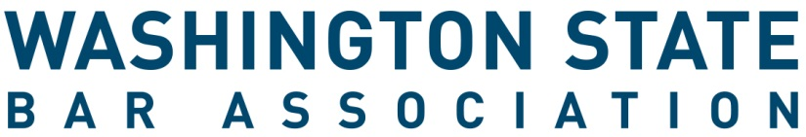

President-elect Application Form

INSTRUCTIONS
- Complete this application form. If you are nominating someone else, ask them to sign it below and submit it along with the required attachments.
- Attach the following:
  - This complete application form (required)
  - Brief (100-word maximum) biographical statement including current occupation, relevant experience, and education
  - Letter of Interest
  - Resume
  - Letters of Support
- Scan and email the signed form and attachments to barleaders@wsba.org. Applications must be received by 5 p.m. PST on Monday, April 17, 2023. Late materials will not be accepted.
- Letters of support, if any, can be sent directly to barleaders@wsba.org by the author.
- Applications will be included in the May Board of Governors meeting materials and posted on the WSBA website.
Candidate for President-elect position of the Washington State Bar Association

I, the undersigned active member of the Washington State Bar Association, am running for the President-elect position.

Click or tap here to enter text. Click or tap here to enter text.
Name of candidate (please print) WSBA Bar #

Signature of Candidate

Signature of Nominator (if relevant) WSBA Bar #

Note: By signing this form, the candidate understands and agrees that as part of the election process for this position, the WSBA routinely checks the grievance and discipline files for any records related to candidates. Thus, the candidate waives confidentiality of these materials to WSBA staff and the Board of Governors.

This form must be filed in the Office of the Executive Director of the WSBA no later than 5 p.m. PDT on April 17, 2023. Filing may be accomplished by emailing the form and attachment(s) to barleaders@wsba.org.

