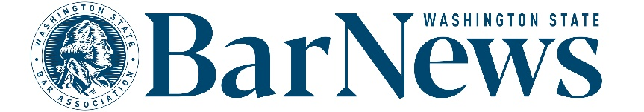

**EAC Meeting Minutes**

Wednesday, April 16, 2-3 p.m.

**Roll call – NO QUORUM (meeting is not able to consist of voting)**

**EAC Members:** Benjamin Gould, David J. Ziff, James Wade, Robbie Philbrick, Suellen   
  
**WSBA Staff:** Kirsten Lacko, Jessica Randklev, Connor Luk, Katrina Mulligan

**Editor’s Report**

* [**AI policy**](https://www.wsba.org/docs/default-source/legal-community/volunteer/volunteer-toolbox/wsba-ai-external-use-policy.pdf?sfvrsn=54a718f1_8)**.** 
  + External parties using an AI recording or notetaking tool must ask the staff liaison in advance (at the time the meeting is scheduled), so participants have a meaningful opportunity to decide whether to participate.
  + Images or text generated with the help of AI **must** be cited.
  + In general, the Bar News team will not be using AI-generated images or text, and we discourage the use of AI in submitted articles or graphics.
* [**Letters policy**](https://www.wsba.org/docs/default-source/news-events/publications/nwlawyer/letters-to-the-editor-policy_final_v2.docx?sfvrsn=8a4408f1_0)**.** 
  + - Discussion of disclaimer language and other potential changes.

**Issue review: David Ziff** reviewed the March issue, available [here](https://wabarnews.org/).

**Pitches of the month for review and discussion:** WSBA staff story ideas to discuss.

**Story ideas** Committee members discussed new story ideas and updates to stories in development.

**Questions/Good of the order/Announcements  
  
Meeting end – 2:39 p.m.**

**Upcoming meeting dates:** May 21, June 18, July 16, August 20, September 17