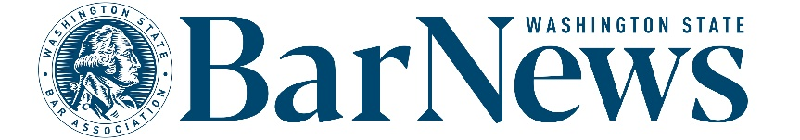

**EAC MEETING MINUTES**

Wednesday, June 18, 2-3 p.m.

**Roll call**

**EAC Members:** Benjamin Gould, Priscilla Moreno, Leron Vandsburger, Robbie Phillbrick, David Ziff, Allison Foreman, Suellen, Thom Williamson   
  
**WSBA Staff:** Katrina Mulligan, Connor Luk, Colin Rigley, Jessica Ranklev   
  
**BOG Liaison:** Kristina Larry

**Editor’s Report**

* [**Letters policy**](https://www.wsba.org/docs/default-source/news-events/publications/nwlawyer/letters-to-the-editor-policy_final_v2.docx?sfvrsn=8a4408f1_0)**.** 
  + - Discussion of future potential changes to the policy. More to come at a later meeting.
* **WSBA articles in progress.** Committee members provided feedback to WSBA staff on potential future story ideas. Committee members also shared their own story ideas and gave updates on any articles in development.
* **Website report.**
  + Top online articles from May 1-31 *(a month with no new issue has less page views):*
    1. [April/May Discipline Notices](https://wabarnews.org/2025/04/14/apr-may-2025-discipline-other-regulatory-notices/) (375 views) (April 2025)
    2. [Amendments to CR 26 and 30](https://wabarnews.org/2024/11/12/amendments-to-cr-26-and-30-will-change-discovery-and-deposition-practice/) (349 views) (November 2024)
    3. [Access to Justice: From Crisis to Change](https://wabarnews.org/2025/04/14/access-to-justice-from-crisis-to-change/) (199 views) (April 2025)
    4. [Alternate Pathways: Your Questions Answered](https://wabarnews.org/2024/07/10/alternate-pathways-your-questions-answered/) (182 views) (July 2024)
    5. [Unpacking the E in DEI](https://wabarnews.org/2023/03/09/unpacking-the-e-in-dei-equity/) (144 views) (May 2023)

**Issue review:** No issue review this month.

**Questions/Good of the order/Announcements**

**Upcoming meeting dates:** July 16, August 20, September 17